Lab 2 – verification TB
Omri Raz – 318671120
Eyal Rothschild – 318793882

25.12.2025

General:
In this lab we asked to create verification to our system from lab 1.
We asked to do the following:
- Clock and Reset Handling: Proper management of Clock and Reset signals, including synchronization, initialization, and ensuring correct behavior at the start and end of the Reset state.
- Create and use coverage.
- Create BFM.
- Create assertions.
- TB needs to take care each module and part in the FSM.
- Ensuring all operational stages are completed with the output held in the FSM, followed by the done_o signal acting as a completion flag in a stable and valid state.

The verification requirements have been fully implemented and verified.
Implementation methods:
- We create “golden model” of the system using python. First, we ran random simulations in TB using randomized input vectors.
The simulation was configured for repeatably, allowing reuse random vectors by applying consistent seed – we enter the random vector to our’s “golden model”, retest and compare the excepted output with our system output.
Theoretically we could test unlimited random vectors, however we decided to test only 15.
In addition, we create local signals in our TB that indicates if there is a mistake.

We also checked edge cases manually – for example:
vec_i = ‘0;
Vec_i =’1;

- we created coverage – ensure that TB checked each module and part in the FSM.
- We created assertions – validate the system’s functional correctness by verifying both its state transition logic and accuracy of its output signals.
- We create BFM to help us with the simulation.
- We ensured all operational stages are completed with the output held in the FSM, followed by the done_o signal acting as a completion flag in a stable and valid state by creating register output.

TB results and examples:

In the next picture we can observe our coverage.
We achieved 100% functional coverage, ensuring that all FSM states were reached and all defined transition were successfully traversed.
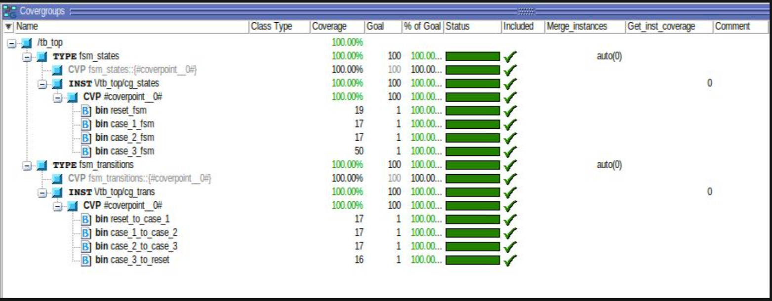

In the next image we can observe our assertion.
All our assertions passed.
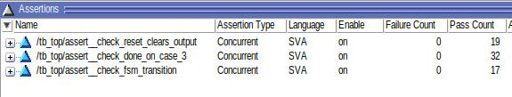

The next photo explain why we got way more “check_done_on_case_3” (we checked done_o in next cycle) assertions – our TB force the system to hold CASE_3 for 3 cycles, in addition this assertion is checked only when rst == 0.
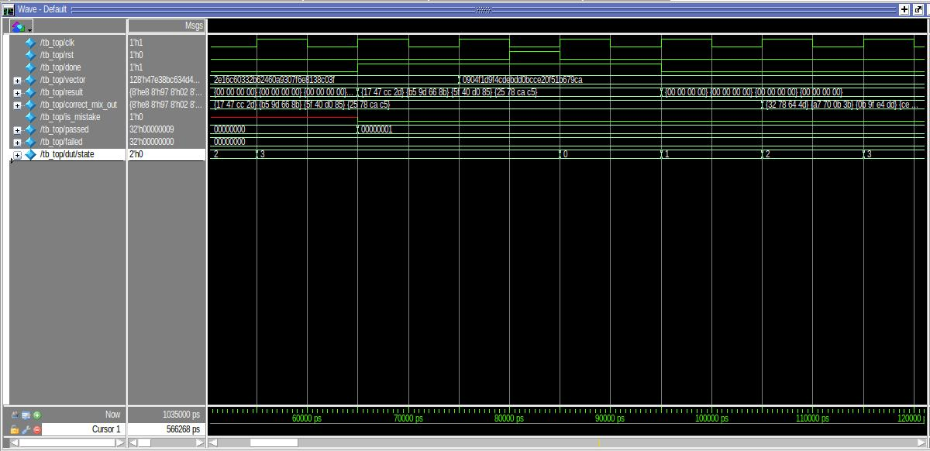

The next photo explains why our reset assertion is bigger than 17:
Our TB is set reset to 1 for 2 cycles at the beginning of the simulation.
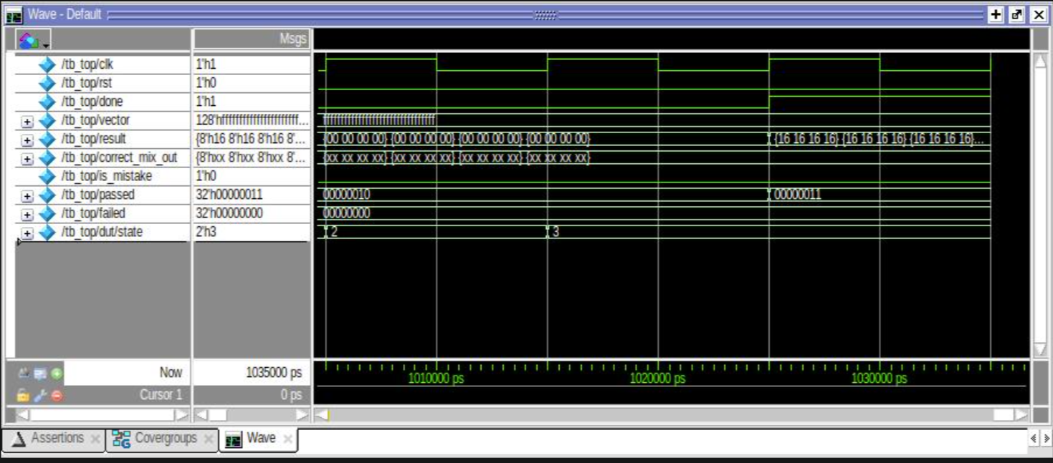

The next photo shows that we passed all our tests!
we can observe the signal “is_mistake” is zero and passed count eqaul to 17 !!!!
good job!

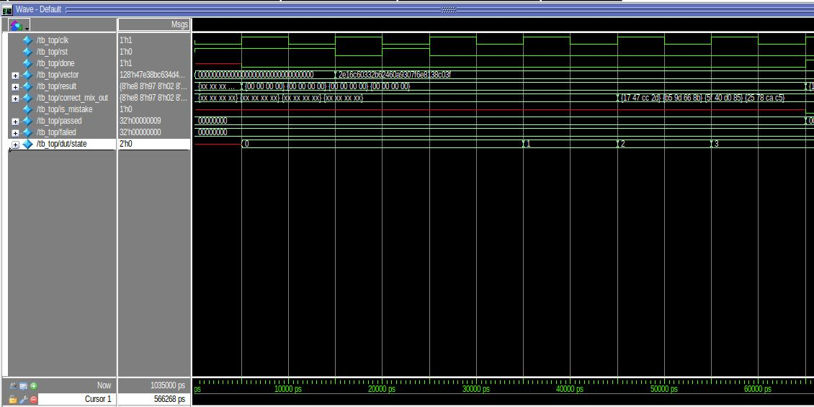

- We added coverage and assertions files in submissions files.

Current FSM diagram:
we changed our FSM due to forum comments and new requirements – done need to be 1 only after all steps are done and the output is stable.
this is our current FSM diagram
